LIGHT BITES
Mac and cheese bites £5.95
Cheesy Garlic bread £5.95
Haloumi Fries with sweet chilli dip £5.95
Corn Dog with fried onions, mustard, and ketchup £5.95
Buffalo Chicken wings with blue cheese sauce £6.95
Cauliflower Wings with homemade ranch dressing £5.95
Onion rings with BBQ sauce £4.95
Mixed Olives £3.95
Fries £3.50

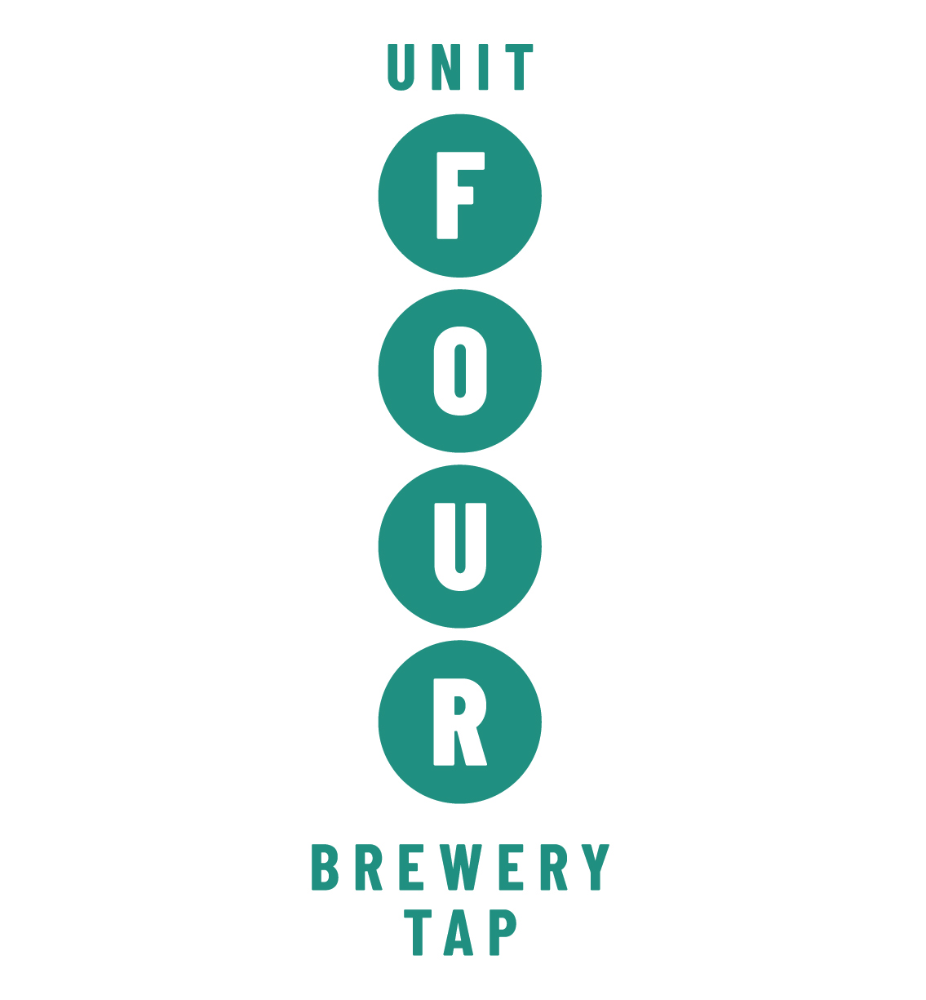
SHARING PLATTERS
Unit 4 Loaded Fries - skin on fries served with a choice of toppings £7.95
Jerk Fries – jerk sauce, onion, and cheese £7.95
Dirty fries – BBQ sauce, bacon, and cheese £7.95
Poutine – Gravy and cheese curds
£7.95
Chilli –Chilli con carne and cheese
£7.95
Pizza –pizza sauce and cheese and chorizo £7.95
Nachos £8.95
Nachos with chilli £10.95
West Coast Sharing Board-Chicken wings, cauliflower wings, corn doggies, haloumi fries served with dip £12.95
Flat Bread – Served with Olives and Hummus £7.95

BURGERS
Beef burger - served with relish, bacon, cheese, lettuce, gherkin, and tomato
£12.45
Pork and apple burger - with maple mustard, cheese, lettuce, gherkin, and tomato 12.45
Spicy chicken fillet burger - with Buffalo sauce, lettuce, tomato. cheese and pineapple £12.00
Spicy bean burger - with vegan mayo (VE) £11.45
Unit 4 Ultimate Burger – double stacked beef burger with cheese, bacon and topped with a fried egg. £14.95
Sloppy joe – Brioche bun, chilli con carne and cheese £10.95
Vegan sloppy joe – Vegan brioche vegan chilli con carne served with a lime wedge (VE) £10.95

A LL OUR BURGERS A RE SERVED WITH SKIN ON FRIES

PIZZA
Margarita – cheese and tomato £9.95
The Hot one – green peppers, onion, chorizo, and jalapeno £10.50
Palma Ham and Rocket – cherry tomato, Palma ham and rocket £10.50
Sweet chilli chicken and mango -sweet chilli chicken, peppers, and mango
£10.50
Veggie Mount Vesuvius – peppers, onion, mushrooms, jalapeno, and a buffalo sauce £10.50
Veggie Deluxe – Peppers, onion, mushrooms £10.50
BBQ Meets on Meat – BBQ sauce, red onion, sausage, bacon, and chorizo
£10.50
Chilli con Pizza – Cheese, tomato and chilli con carne £10.50
Vegan Margarita – vegan cheese with cherry tomato £9.95
Vegan BBQ Deluxe – vegan mince in BBQ sauce with peppers and onion
£10.50

MAINS AND SALADS
Fish and Chips £11.95
Greek Salad with flat bread £7.95
Chicken Caesar salad £8.95
Avocado and pomegranate salad, lemon dressing granola, £5.95
Hunters Chicken – BBQ sauce, cheese bacon and fries £12.95
Chilli con carne £9.95
Vegan Chilli £9.95

DESSERTS -
Chocolate heaven pizza – chocolate, banana, and marshmallow in a folded pizza £8.95
Chocolate brownie – with vanilla Ice cream £5.95
Sticky toffee pudding £5.95
Ice cream selection £5.95

